First Impressions
Write the words or phrases which come to mind when you look at these photos. Afterwards consider which ones most impact your impression of this leader. Use the symbol ↑ to indicate if the word has a positive association, ↓ if negative, and * if neutral

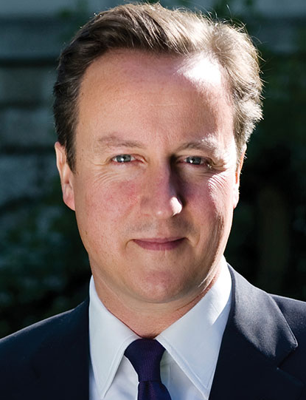

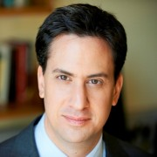



PTO

First Impressions
Write the words or phrases which come to mind when you look at these photos. Afterwards consider which ones most impact your impression of this leader. Use the symbol ↑ to indicate if the word has a positive association, ↓ if negative, and * if neutral
