The Leaders’ Debate Report Card

How did the party leaders perform in the Leaders’ Debate?

As you watch the debate, write down your thoughts on the leaders on their report card.
You could comment on and grade the leader’s general performance or performance on specific topics. You can comment on as many (or as few) topics as you want. You can also comment on their overall performance at the end.
You can also use the recording devices (audio and video) placed on your table or in the room to make your comments as well.

Don’t forget to give them ‘Overall Comments’ and a ‘Final Grade’ at the end!
A: Outstanding
B: Above average
C: Could do better
D: Poor
F: Fail

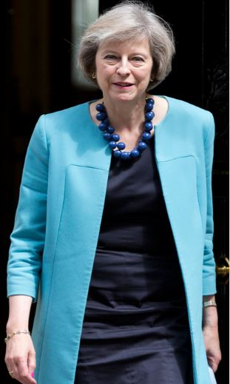
Theresa May
The Conservative Party

Topic: Grade:
Comments:

Topic: Grade:
Comments:

Topic: Grade:
Comments:

Theresa May
The Conservative Party

Topic: Grade:
Comments:

Topic: Grade:
Comments:

Topic: Grade:
Comments:

Final comments
Final Grade:

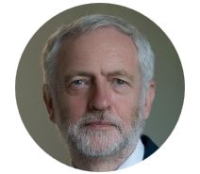
Jeremy Corbyn
The Labour Party

Topic: Grade:
Comments:

Topic: Grade:
Comments:

Topic: Grade:
Comments:

Jeremy Corbyn
The Labour Party

Topic: Grade:
Comments:

Topic: Grade:
Comments:

Topic: Grade:
Comments:

Final comments
Final Grade:

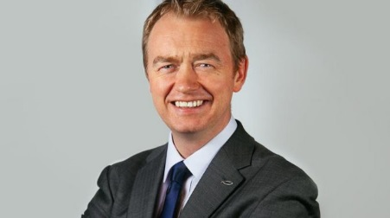
Tim Farron
The Liberal Democrats

Topic: Grade:
Comments:

Topic: Grade:
Comments:

Topic: Grade:
Comments:

Tim Farron
The Liberal Democrats

Topic: Grade:
Comments:

Topic: Grade:
Comments:

Topic: Grade:
Comments:

Final comments
Final Grade:

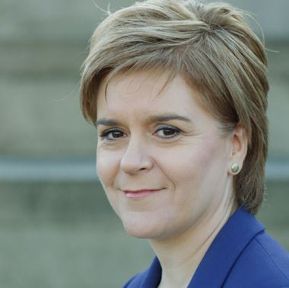
Nicola Sturgeon
The Scottish National Party

Topic: Grade:
Comments:

Topic: Grade:
Comments:

Topic: Grade:
Comments:

Nicola Sturgeon
The Scottish National Party

Topic: Grade:
Comments:

Topic: Grade:
Comments:

Topic: Grade:
Comments:

Final comments
Final Grade:

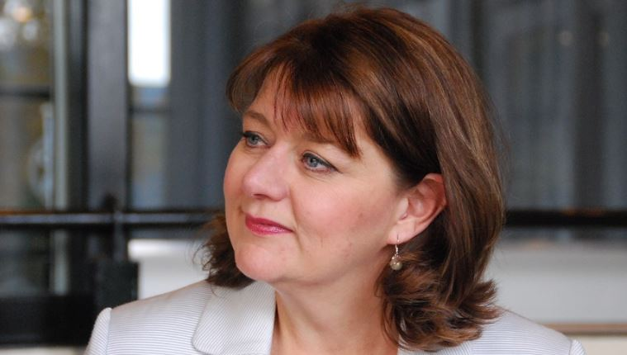
Leanne Wood
Plaid Cymru

Topic: Grade:
Comments:

Topic: Grade:
Comments:

Topic: Grade:
Comments:

Leanne Wood
Plaid Cymru

Topic: Grade:
Comments:

Topic: Grade:
Comments:

Topic: Grade:
Comments:

Final comments
Final Grade:

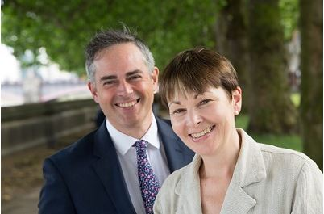
Caroline Lucas or
Jonathan Bartley
The Green Party

Topic: Grade:
Comments:

Topic: Grade:
Comments:

Topic: Grade:
Comments:

Caroline Lucas or
Jonathan Bartley
The Green Party

Topic: Grade:
Comments:

Topic: Grade:
Comments:

Topic: Grade:
Comments:

Final comments
Final Grade:

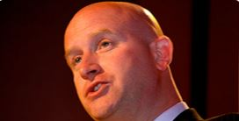
Paul Nuttall
The UK Independence Party

Topic: Grade:
Comments:

Topic: Grade:
Comments:

Topic: Grade:
Comments:

Paul Nuttall
The UK Independence Party

Topic: Grade:
Comments:

Topic: Grade:
Comments:

Topic: Grade:
Comments:

Final comments
Final Grade:

Leader:

Topic: Grade:
Comments:

Topic: Grade:
Comments:

Topic: Grade:
Comments:

Topic: Grade:
Comments:

